Name: Gerald P. Regala

Course | Year:

Date: October 27, 2022

**(MIDTERM ACT-3) HTML & CSS [Mobile Responsive]**

Create the following html forms format with an HTML structures in the content. (*This is an example of a “Hair Salon/Barbershop” website.)*

**TASK #1.1 - 20 points:** For the structure, you must have the structure of an HTML includes these following: **header, nav, main, footer**

Additional tags are: **images, divs, headings/title, texts, buttons**

**TASK #1.2 - 30 points:** For Responsive CSS (Tablet Layout):

* **Tablet Layout must have this ffg example:**
  + Header has Navigation menu
  + Main has:
    - Banner/Hero Section (e.g., Hairday)
    - 2 Buttons (e.g., Book Now, Learn More)
    - Image (it must have a banner image)
  + Our Services section has 3 cards (e.g., Men’s Haircut, Nail’s Cut, Body Massage)
  + Footer has:
    - Footer logo
    - Copyright text
  + Margins must be 15%.

**TASK #2 & #3 - 50 points:** For Responsive CSS (Tablet & Mobile Layout):

* **TASK #2 – Tablet Layout must have this ffg example:**
  + All contents are centered align.
  + Text sizes for paragraphs must be 16px.
  + Margins must be 10%.
  + Buttons must be 24px & 36px in paddings.
* **TASK #3 –Mobile Layout must have this ffg example:**
  + All contents are centered align.
  + Text sizes for paragraphs must be 14px.
  + Margins must be 5%.
  + Buttons must be 18px & 32px in paddings.

Paste your HTML Code here:

**//THIS IS THE STARTING CODE**

Delete this text to write your code.

Delete this text to write your code.

Delete this text to write your code.

**//THIS IS THE END OF CODE**

Explain your code (HTML & CSS) here: [Minimum of 300 words.]

Delete this text to write your explanation.

**Paste your screenshot here:**

You can download this logo.

Just right-click the image then click “Save”.

Additional resources: Image and Logo are saved in the WEEK10 file tab (inside the ACT3 Folder); you can download it on the said destination.

**TASK #1: WEB LAYOUT**

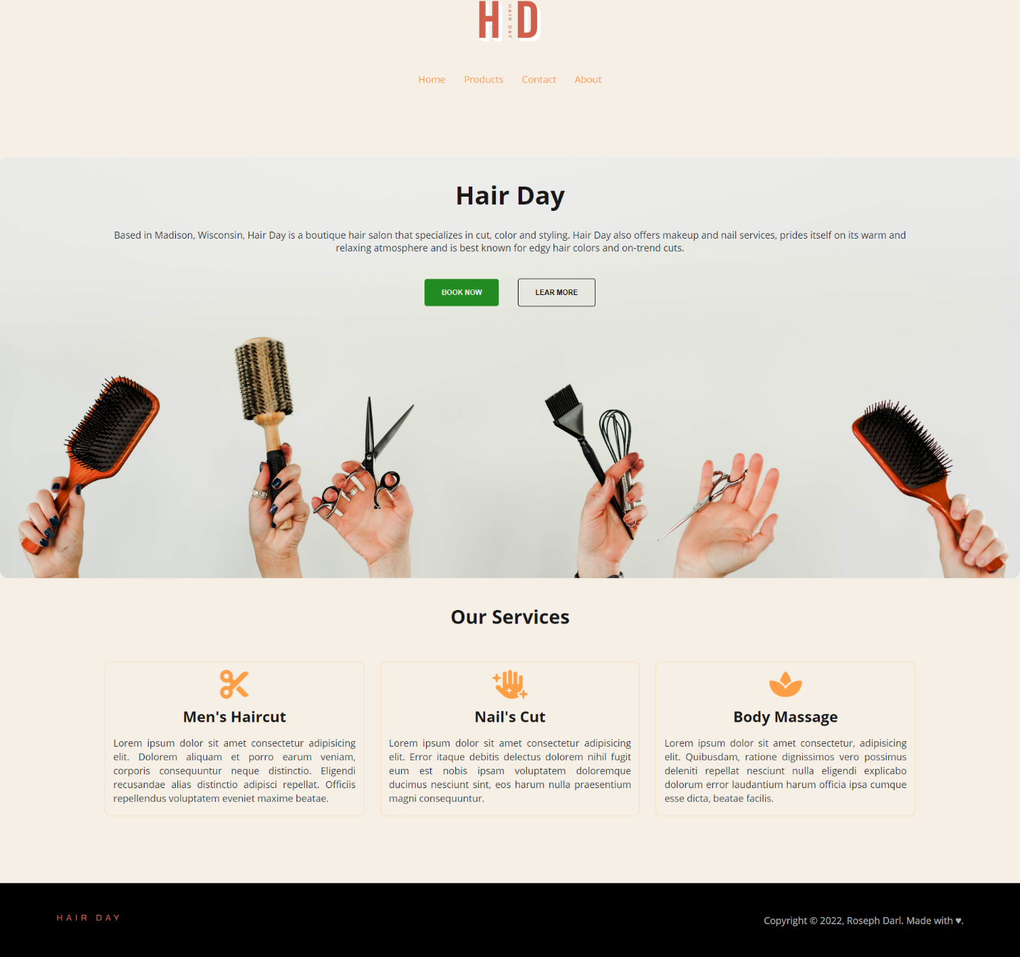

**TASK #2: TABLET LAYOUT**

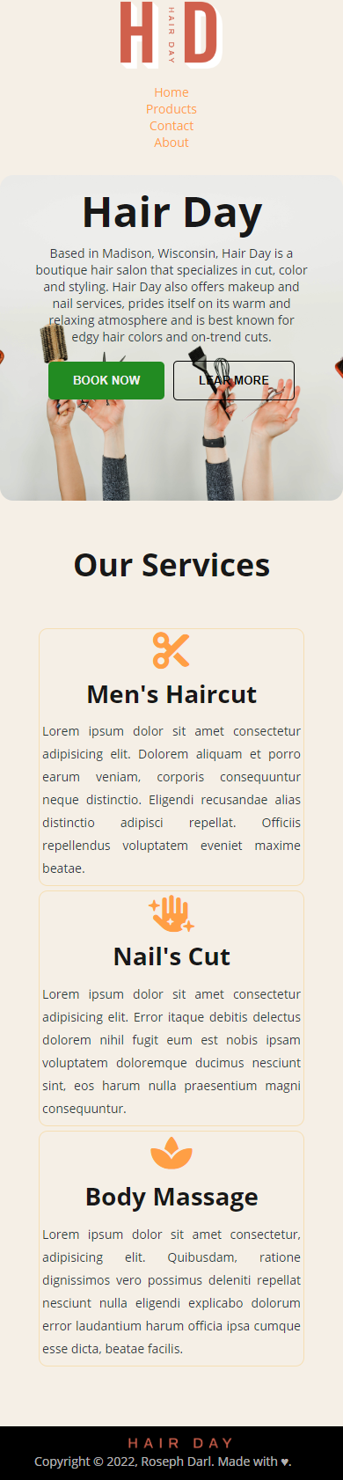

**TASK #3: MOBILE LAYOUT**

Goodluck and keep going! You can do it!

___________________

**Roseph Darl Tungul**

Instructor